**Tab 5- Kids Zone**

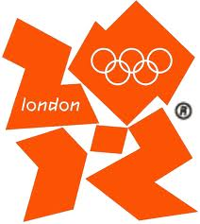  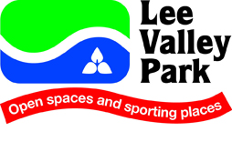 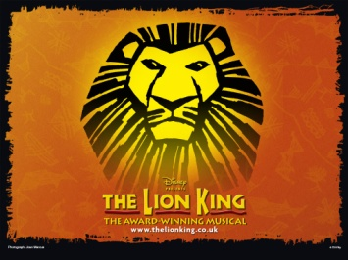 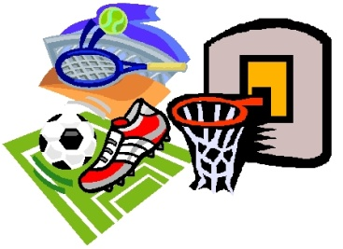 

Each of the above icons will be a link to games, information, a camp survey etc. For now the collage of pics will do and hopefully we can add the exact links when we get back from Africa. For example the link for the first Olympic icon will be this:

<https://getset.london2012.com/en/resources>